17. Develop a system using UML for Vehicle Registration Number Registering system. ACTIVITY DIAGRAM

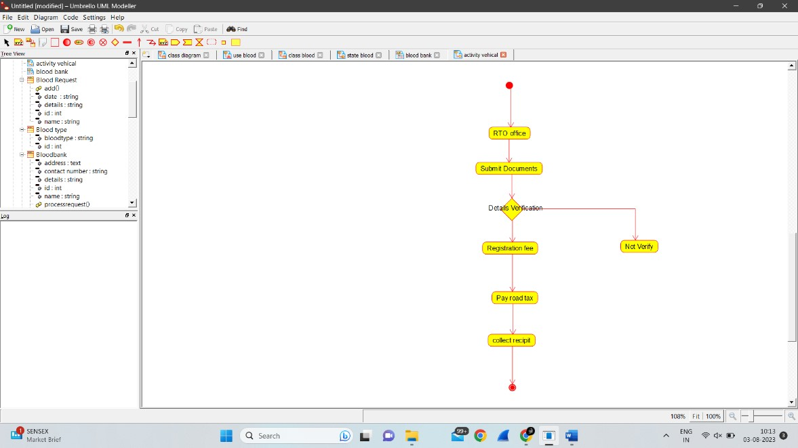

COLLOBORATION DIAGRAM

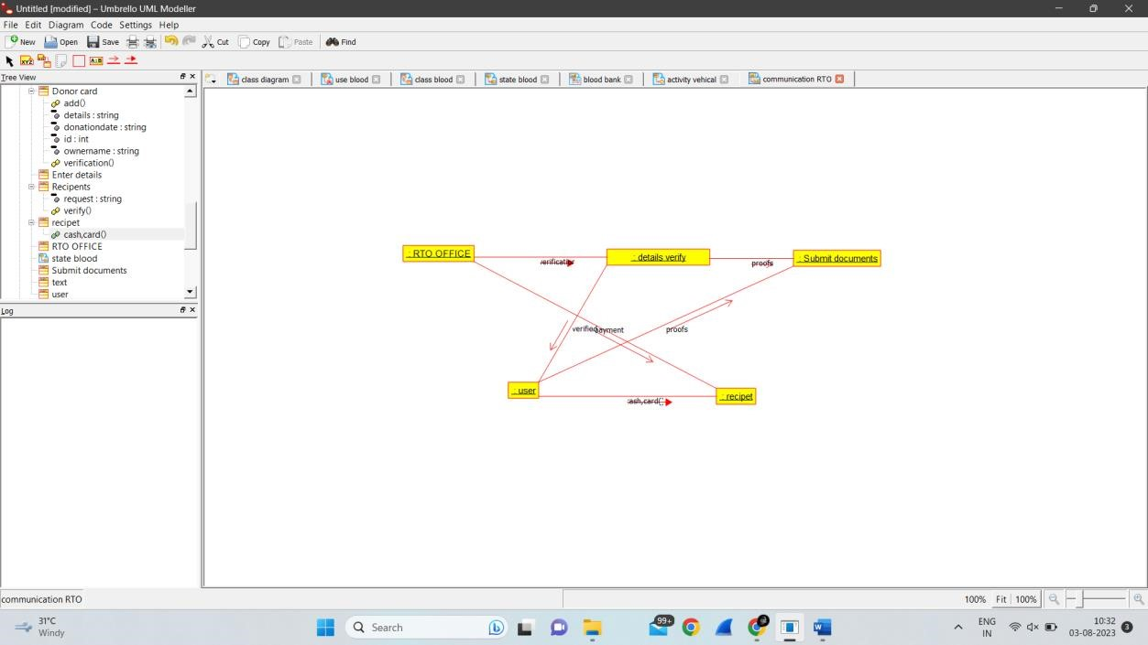

STATE DIAGRAM

